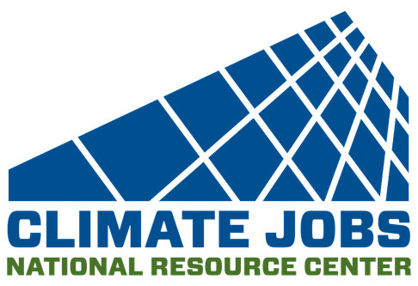
Location: Remote
Status: Attorney
Climate Jobs National Resource Center (CJNRC) is hiring an Attorney. The Attorney will have two years to 10 years of legal experience to work in-house on all aspects of the organization’s mission.

Responsibilities:
The in-house attorney would work under the direction of CJNRC’s general counsel. This job does not involve litigation, but the scope of the work includes a wide variety of legal work, including:
- Program support: CJNRC is dedicated to advocating for state and local initiatives. This role will provide program support by analyzing applicable procurement laws, laws and regulations governing labor standards, and laws governing restrictions on local legislative initiatives. The attorney hired for this position will help identify law reform possibilities and legal obstacles that need to be overcome, including difficulties posed by federal and state preemption.
- Institutional support: CJNRC operates in a highly regulated area. A number of federal, state and local laws will affect its work or impose burdens that it must meet. Analysis of these regulations and navigating the regulatory shoals they create is an important part of the legal work.
Qualifications
- A strong commitment to progressive social change, racial justice, a familiarity with the issues that are central to CJNRC’s work and vision, and a commitment to community and labor organizing.
- 2-10 years of experience of legal experience, preferably in the labor relations field.
- A strong interest in supporting strategic campaigns, policy or research for unions or other advocacy organizations.
- Familiarity with corporate research, financial analysis, and employment law
- Strong technical research skills.
- Demonstrated ability to work effectively in politically sensitive and high-pressure environments.
- Willingness to travel extensively when it is safe to do so.
- Willingness to work remotely.

Working conditions: This is a full-time remote position. Long hours will be required on occasion. When conditions are amenable, the position will require some travel. CJNRC will follow public health guidance related to the COVID-19 pandemic.
Compensation: The salary range for the position is $85,000 to $125,000, depending upon the candidate’s experience. CJNRC also offers an excellent benefits package that includes employer-paid medical and dental plans for full-time staff and their qualified dependents.

To Apply: CJNRC expects to complete the hiring process in the next two months and anticipates that the attorney hired for this position will begin work on October 31, 2022. Send applications to Walter Meginniss at tmeginniss@grmny.com
CJNRC is committed to equal opportunity, and encourages applicants of all ages, races, sexual orientations, genders, national origins, ethnicities, religions, and veteran status. We encourage people from diverse backgrounds and experiences related to our core organizational values and objectives to apply.

